**Stakeholder Management Plan**

**FOR**

**APWA Self-Assessment**

**Date**

**3-19-15**

**Introduction**

The Stakeholder Management Plan for APWA Self-Assessment will be used to identify and classify project stakeholders; determine stakeholder power, interest, and influence; and analyse the management approach and communication methodology for project stakeholders. This will allow us to identify key influential stakeholders to solicit input for project planning and gain support as the project progresses. This will benefit the project by minimizing the likelihood of encountering competing objectives and maximizing the resources required to complete the project.

Inputs to the Stakeholder Management Plan include the project charter, procurement documents, enterprise environmental factors, and organizational process assets. The tools and techniques to be applied are described herein, and the outputs include Stakeholder Registry.

Early identification and communication with stakeholders is imperative to ensure the success of the APWA Self-Assessment Project by gaining support and input for the project. Some stakeholders may have interests which may be positively or negatively affected by the APWA Self-Assessment Project, or who can themselves affect the Project. By initiating early and frequent communication and stakeholder management, we can more effectively manage and balance these interests while accomplishing all project tasks.

**Identify Stakeholders**

The APWA Self-Assessment Project Team will meet in order to identify stakeholders for the project. The meeting will include the primary project team and project manager. The team will focus on internal stakeholders within the City of Carlsbad. These stakeholders may include functional managers, operations personnel, finance personnel, warehouse and material handlers, and any other City employee who will be affected by the APWA Self-Assessment Project. The team will also focus on external stakeholders. These will include the project consultant and the APWA audit team.

The following criteria will be used to determine if an individual will be included as a stakeholder

1. Will the person or their organization be directly or indirectly affected by this project?
2. Does the person or their organization hold a position from which they can influence the project?
3. Does the person have an impact on the project’s resources (material, personnel, funding)?
4. Does the person or their organization have any special skills or capabilities the project will require?
5. Does the person potentially benefit from the project or are they in a position to resist this change?

Any individual who meets one or more of the above criteria will be identified as a stakeholder. Stakeholders from the same organization will be grouped in order to simplify communication and stakeholder management.

**Key Stakeholders**

As a follow on to Identify Stakeholders, the project team will identify key stakeholders who have the most influence on the project or who may be impacted the most by it. These key stakeholders are those who also require the most communication and management which will be determined as stakeholders are analysed. Once identified, the Project Manager will develop a plan to obtain their feedback on the level of participation they desire, frequency and type of communication, and any concerns or conflicting interests they have.

Based on the feedback gathered by the project manager, the determination may be made to involve key stakeholders on steering committees, focus groups, gate reviews, or other project meetings or milestones. Thorough communication with key stakeholders is necessary to ensure all concerns are identified and addressed and that resources for the project remain available.

|  |  |  |  |  |  |
| --- | --- | --- | --- | --- | --- |
| Key Stakeholders | **Unaware** | **Resistant** | **Neutral** | **Supportive** | **Leading** |
| Project Sponsor- Pat Thomas |  |  |  |  |  |
| Project Manager- Craddock Stropes |  |  |  |  |  |
| Property & Fleet Manager-Joe Garuba |  |  |  |  |  |
| Utilities Director-Wendy Chambers |  |  |  |  |  |
| Streets Manager-John Maashoff |  |  |  |  |  |

**Stakeholder Analysis**

Once all APWA Self-Assessment Project stakeholders have been identified, the project team will categorize and analyze each stakeholder. The purpose of this analysis is to determine the stakeholders’ level of power or influence, plan the management approach for each stakeholder, and to determine the appropriate levels of communication and participation each stakeholder will have on the project.

The project team will categorize stakeholders based on their organization or department. Once all stakeholders have been categorized, the project team will utilize a power/interest matrix to illustrate the potential impact each stakeholder may have on the project. Based on this analysis the project team will also complete a stakeholder analysis matrix which illustrates the concerns, level of involvement, and management strategy for each stakeholder.

The chart below will be used to establish stakeholders and their levels of power and interest for use on the power/interest chart as part of the stakeholder analysis. Note: 1 = low and 5 = high.

|  |  |  |  |  |
| --- | --- | --- | --- | --- |
| **Key** | **Organization** | **Name** | **Power (1-5)** | **Interest (1-5)** |
| A | PW Director | P. Thomas | 5 | 5 |
| B | Project Mgr | C. Stropes | 4 | 5 |
| C | Consultant | TBD | 3 | 5 |
| D | Utilities Director | W. Chambers | 2 | 2 |
| E | Transportation Super | J. Maashoff | 2 | 1 |
| F | Engineering | D. Bilse | 2 | 1 |
| G | Property & Fleet | J. Garuba | 2 | 3 |

Below is the power/interest chart for the APWA Self-Assessment Project stakeholders. Each letter represents a stakeholder in accordance with the key in the chart above.

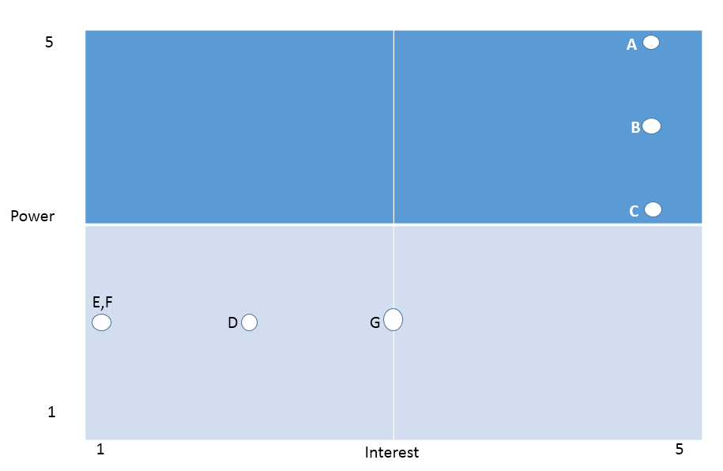

Based on the power and interest analysis and chart above, stakeholders D, E, and F will require minimal management effort as they reside in the lower left quadrant of the matrix. Stakeholder A, B, C in the upper left quadrant, must be kept satisfied by ensuring concerns and questions are addressed adequately. Stakeholder G, in the lower middle quadrant, must be kept informed through frequent communication on project status and progress. Stakeholders A and B, in the upper right quadrant, are key players and must be involved in all levels of project planning and change management. Additionally, stakeholders B and C should be participatory members in all project status meetings, gate reviews, and ad hoc meetings as required.

The stakeholder analysis matrix will be used to capture stakeholder concerns, level of involvement, and management strategy based on the stakeholder analysis and power/interest matrix above. The stakeholder analysis matrix will be reviewed and updated throughout the project’s duration in order to capture any new concerns or stakeholder management strategy efforts.

|  |  |  |  |
| --- | --- | --- | --- |
| **Stakeholder** | **Concerns** | **Quadrant** | **Strategy** |
| A | Ensure that the Self-Assessment is accurate and completed in a timely fashion | Keep Satisfied | Communicate project specifications as required |
| B | Resource and scheduling constraints to gather data, getting data in a timely fashion | Key Player | Solicit stakeholder as member of steering committee and obtain feedback on project planning. Frequent communication and addressing concerns are imperative |
| C | Ensuring on time delivery of materials | Minimal Effort | Communicate project schedule and material requirements ahead of time to ensure delivery |
| D | Freeing up resources to gather data won’t impact day to day operations | Key Player | Provide detailed list with what data needs to be gathered and a time estimate for the data mining. |
| E | Accuracy of data that resides in WM system | Minimal Effort | Assist in QA/QC and data scrub |
| F | Time involved in collecting data that they currently don’t possess | Minimal Effort | Help to set up process for gather data |
| G | Effort involved in pull data out of 3 systems | Key Player | Allow technical staff to work with stakeholder to answer questions and address concerns and provide tools for data extraction. |

**Manage Stakeholder Engagement – Stakeholder Communications**

|  |  |  |  |
| --- | --- | --- | --- |
| **Stakeholder** | **Communication Need** | **Method/Medium** | **Timing/Frequency** |
| Project Sponsor- Pat Thomas | **Results & Recommendations** | **Written Communication/Meetings** | **Monthly** |
| Project Manager- Craddock Stropes | **Data/Discussion** | **All** | **On-going** |
| Project Consultant | **Data/Discussion** | **All** | **On-going** |
| Property & Fleet Manager-Joe Garuba | **Data/Discussion** | **Email/Meetings** | **Monthly** |
| Utilities Director-Wendy Chambers | **Data/Discussion** | **Email/Meetings** | **Monthly** |
| Streets Manager-John Maashoff | **Data/Discussion** | **Email/Meetings** | **Monthly** |
| Risk Manager-Ed Garbo | **Data/Discussion** | **Email/Meetings** | **Quarterly** |
| City Attorney-Ron Kemp | **Data/Discussion** | **Email/Meetings** | **Quarterly** |
| Assistant City Manager-Gary Barberio | **Data/Discussion** | **Email/Meetings** | **Quarterly** |
| Finance Director- Kevin Branca | **Data/Discussion** | **Email/Meetings** | **Quarterly** |
| I.T. Director- Tina Steffan | **Data/Discussion** | **Email/Meetings** | **Quarterly** |
| H.R. Manager- Cheri Abbott | **Data/Discussion** | **Email/Meetings** | **Quarterly** |
| City Manager- Steve Sarkozy | **Results** | **Written communication** | **At completion of report** |
| City council | **Results** | **Written communication** | **At completion of report** |
| Emergency Preparedness Mgr-David Harrison | **Data/Discussion** | **Email/Meetings** | **Quarterly** |
| Communications Mgr-Kristina Ray | **Data/Discussion** | **Email/Meetings** | **Quarterly** |
| CED Director-Glen Van Peski | **Data/Discussion** | **Email/Meetings** | **Quarterly** |
| Finance Mgr-Colette Wengenroth | **Data/Discussion** | **Email/Meetings** | **Quarterly** |
| Traffic Engineer- Doug Bilse | **Data/Discussion** | **Email/Meetings** | **Quarterly** |
| Senior Engineer-Marshal Plantz | **Data/Discussion** | **Email/Meetings** | **Quarterly** |
| Environmental Mgr-Elaine Lukey | **Data/Discussion** | **Email/Meetings** | **Quarterly** |
| Engineering Mgr-Patrick Vaughn | **Data/Discussion** | **Email/Meetings** | **Quarterly** |
| Management Analyst-Fred Gaines Jr. | **Data/Discussion** | **Email/Meetings** | **Quarterly** |
| Management Analyst-Steve Hodges | **Data/Discussion** | **Email/Meetings** | **Quarterly** |
| Program Mgr- Lolly Sangster | **Data/Discussion** | **Email/Meetings** | **Quarterly** |
| Management Analyst-Ligeia Heagy | **Data/Discussion** | **Email/Meetings** | **Quarterly** |
| Engineering Mgr-Kristen Plonka | **Data/Discussion** | **Email/Meetings** | **Quarterly** |
| Utilities Manager- Don Wasko | **Data/Discussion** | **Email/Meetings** | **Quarterly** |
| Utilities Manger- Angel Quintero | **Data/Discussion** | **Email/Meetings** | **Quarterly** |
| Public Works Administrative Team | **Data/Discussion** | **Email/Meetings** | **Quarterly** |
| Public Works Business Systems Specialists | **Data/Discussion** | **Email/Meetings** | **Quarterly** |
| Senior Management Analyst-Bonnie Elliott | **Data/Discussion** | **All** | **On-going** |
| Business System Specialist- Greg MacLellan | **Data/Discussion** | **All** | **On-going** |
| Management Analyst-Christie Marcella | **Data/Discussion** | **All** | **On-going** |
| Management Analyst-Jennifer Marinov | **Data/Discussion** | **All** | **On-going** |

**Control Stakeholder Engagement**

The APWA information management system will provide a tool and repository for the Self-Assessment data to capture, store and distribute information to stakeholders as well as the APWA audit team. The APWA information needs will be the primary driver of what is collected in the information management system, and how it is distributed. The end product will be a completed APWA Self-Assessment.

# Sponsor Acceptance

Approved by the Project Sponsor:

Date:

Pat Thomas

Public Works Director